**ABSTRACT**

Now a -days there are a lot of service providers available in every business. There is no shortage of customers in any options. Mainly, in the banking sector when people want to keep their money safely, they have a lot of options. As a result, customer churn and loyalty of customers have become a major problem for most banks. In this paper, a method that predicts customer churn in banking using Machine learning with ANN. This research promotes the exploration of the likelihood of churning by customer loyalty. The logistic regression, random forest, decision tree and naive Bayes Machine Learning algorithms are used in this study. Kera’s and TensorFlow are ANN concepts that are also used in this study. This study is done on a dataset called churn modelling. The dataset was collected from Kaggle. The results are compared to find an appropriate model with higher accuracy. As a result, the Random Forest algorithm achieved higher accuracy than other algorithms. And accuracy was nearly 87%. The least accuracy was achieved by the Decision tree algorithm and it was 78.59% accuracy. The number of service providers is increasing very rapidly in every business. These days, there is no shortage of options for customers in the banking sector when choosing where to put their money. As a result, customer churn and engagement have become one of the top issues for most banks. In this project, a method to predict the customer churn in a Bank, using machine learning techniques, which is a branch of artificial intelligence, is proposed. The research promotes the exploration 5 of the likelihood of churn by analysing customer behaviour. Customer Churn has become a major problem in all industries including the banking industry and banks have always tried to track customer interaction so that they can detect the customers who are likely to leave the bank.

**TABLE OF CONTENT**

|  |  |  |
| --- | --- | --- |
| CHAPTER NO. | TITLE | PAGE NO |
|  | ABSTRACT  TABLE OF CONTENT | 4  5 |
| 1 | INTRODUCTION | 6-9 |
| 2 | LITERATURE SURVEY | 10-11 |
| 3 | METHODOLOGY | 12-13 |
| 4 | FEASIBILITY STUDY  4.1 PROJECT REQUIREMENT  4.2 SYSTEM ARCHITECTURE | 14  15  16 |
| 5 | RESULT AND DISCUSSION | 17-21 |
| 6 | ALGORITHM AND TECHNIQUES  6.1 RANDOM FOREST CLASSIFIER | 22  23 |
| 7 | REFERENCES | 24 |
| 8 | CONCLUSION | 25 |

1. **INTRODUCTION**

Churning means a customer who leaves one company and transfers to another company. It is not only a loss in income but also other negative effects on the operations and also mainly Customer Relation Management is very important for banking when the company considers it as they try to establish long-term relationships with customers and also it will lead to increase their customer base. The service provider's challenges are found in the behaviour of the customer and their expectations. In the current generation, people are mostly educated compared to previous generations. So, the current generation of people is expecting more policies and their diverse demand for connectivity and innovation. This advanced knowledge is leading to changes in purchase behaviour. This is a big challenge for current service providers to think innovatively to reach their expectations. Private sectors need to recognize customers Liu and Shih strengthen this argument in their paper by indicating that increasing pressures on companies to develop new and innovative ideas in marketing, to meet customer expectations and increase

loyalty and retention. For Customers, it is very easy to transfer their relations from one bank to another bank. Some customers might be keeping their relationship status null that means they will keep their account status inactive. By keeping this account inactive it might be the customer transferring their relationship with another

bank. There are different types of customers are in the bank. Farmers are one of the major customers to the banks they will expect fewer monthly chargers as they were financially low. Businessperson, are also one of the major and important customers because a lot of transactions with huge amount is done by them only usually. These

customers will expect better service quality. One of the most important categories was Middle-class customers, mostly in every bank these peoples are more than the type of customers. These people will expect fewer monthly charges, better service quality, and new policies. So, maintaining different types of customers is not that easy. They need to consider customers and their needs to resolve these challenges delivering reliable service on 5 time and within budget to customers. While maintaining a good working partnership with them is another significant challenge for them. If they failed to resolve these 8 challenges this may cause churning. Recruiting a new customer is more expensive and harder than keeping already customers. Customers holding on the other hand is usually more expensive because they have already gained the confidence and loyalty of present customers. So, the need for a system that can predict customer churn effectively in the early stages is very important for any banking. This paper aims at a framework that can predict the customer churning banking sectors using some machine learning algorithms with ANN.

**Existing System:**

Predicting player behaviour and customer churn is one of the central and most common challenges in game analytics. A crucial stage in developing customer churn prediction model is feature engineering. In the mobile gaming field, features are commonly constructed from the raw behavioural telemetry data which leads to challenges related to the establishment of meaningful features and comprehensible feature frameworks. This research proposes an extended Recency, Frequency, and Monetary value (RFM) feature framework for churn prediction in the mobile gaming field by incorporating features related to user Lifetime, Intensity and Rewards (RFMLIR). The proposed framework is verified by exploring behavioural differences between churners and non-churners within the established framework for different churn definitions and definition groups by applying robust exploratory methods and developing univariate and multivariate churn prediction models. Although feature importance varies among churn definitions, long term frequency feature stands out as the most important feature. The top five most important features distinguished by the multivariable churn prediction models include long and

short term frequency features, monetary, intensity and lifetime.

Disadvantages:

● They done only Feature Engineering and analysis, no a practical

model

● No predictive AI model is build

**MACHINE LEARNING**

Machine learning is to predict the future from past data. Machine learning (ML) is a type of artificial intelligence (AI) that provides computers with the ability to learn without being explicitly programmed. Machine learning focuses on the development of Computer Programs that can change when exposed to new data and the basics of Machine Learning, implementation of a simple machine learning algorithm using python. Process of training and prediction involves the use of specialized algorithms. It feeds the training data to an algorithm, and the algorithm uses this training data to give predictions on a new test data. Machine learning can be roughly separated into three categories. There is supervised learning, unsupervised learning and reinforcement learning. Supervised learning programs are both given the input data and the corresponding labelling to learn data has to be labelled by a human being beforehand. Unsupervised learning has no labels. It provided the learning algorithm. This algorithm has to figure out the clustering of the input data. Finally, Reinforcement learning dynamically interacts with its environment and it receives positive or negative feedback to improve its performance. Data scientists use many different kinds of machine learning algorithms to discover patterns in python that lead to actionable insights. At a high level, these different algorithms can be classified into two groups based on the way they “learn” about data to make predictions: supervised and unsupervised learning. Classification is the process of predicting the class of given data points. Classes are sometimes called as targets/ labels or categories. Classification predictive modelling is the task of approximating a mapping function from input variables(X) to discrete output variables(y). In machine learning and statistics, classification is a supervised learning approach in which the computer program learns from the data input given to it and then uses this learning to classify new observations. This data set may simply be biclass (like identifying whether the person is male or female or that the mail is spam or non-spam) or it may be multi-class too. Some examples of classification problems are: speech recognition, handwriting recognition, biometric identification, document classification etc. Supervised machine learning is the majority of practical machine learning using supervised learning. Supervised learning is where you have input variables (X) and an output variable (y) and use an algorithm to learn the mapping function from the input to the output is y = f(X). The goal is to approximate the mapping function so well that when you have new input data (X) that you can predict the output variables (y) for that data. Techniques of Supervised Machine Learning algorithms include logistic regression, multiclass classification, Decision Trees and support vector machines etc. Supervised learning requires that the data used to train the algorithm is already labelled with correct answers. Supervised learning problems can be further grouped into Classification problems. This problem has as goal the construction of a succinct model that can predict the value of the dependent attribute from the attribute variables. The difference between the two tasks is the fact that the dependent attribute is numerical for categorical for classification. A classification model attempts to draw some conclusion from observed values. Given one or more inputs a classification model will try to predict the value of one or more outcomes. A classification problem is when the output 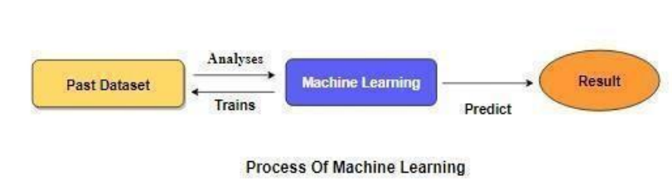variable is a category, such as “red” or “blue”.

**Figure 1.1**

**Preparing the Dataset**:

This dataset contains 10000 records of features extracted from Bank Customer Data, which were then classified into 2 classes:

● Exit

● Not Exit

**Proposed System**:

The proposed method is to build a BANK CUSTOMER CHURN Prediction using Machine learning Technique. We are going to develop a AI based model, we need data to train our model. We can use BANK CUSTOMER Dataset in order to train the model. To use this dataset, we need to understand what the intents that we are going to train are. An intent is the intention of the user interacting with a predictive model or the intention behind each Data that the Model receives from a particular user. According to the domain that you are developing an AI solution, these intents may vary from one solution to another. The strategy is to define different intents and make training samples for those intents and train your AI model with those training sample data as model training data and intents as model training categories. The model is build using the process of vectorisation where the vectors made to understand the data. To use different Algorithm, we can get a better AI model and best accuracy. After building a model we evaluate the model using different metrics like confusion metrics, precision, recall, Sensitivity and f1 score.



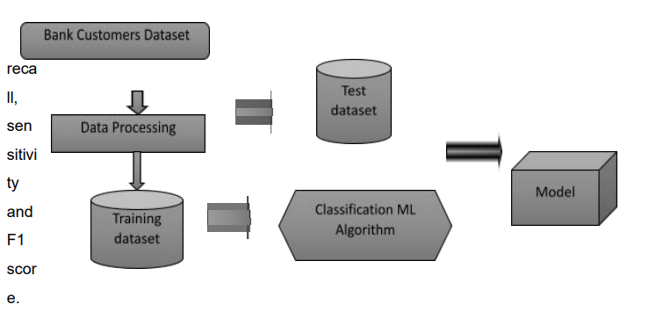

1. **LITERATURE SURVEY**

A literature review is a body of text that aims to review the critical points of current knowledge on and/or methodological approaches to a particular topic. It is a secondary source and discusses published information in a particular subject area and sometimes information in a particular subject area within a certain time period. Its ultimate goal is to bring the reader up to date with current literature on a topic and forms the basis for another goal, such as future research that may be needed in the area and precedes a research proposal and may be just a simple summary of sources. Usually, it has an organizational pattern and combines both summary and synthesis. A summary is a recap of important information about the source, but a synthesis is a reorganization, reshuffling of information. It might give a new interpretation of old material or combine new with old interpretations or it might trace the intellectual progression of the field, including major debates. Depending on the situation, the literature review may evaluate the sources and advise the reader on the most pertinent or relevant of them. A comparison of machine learning techniques for customer churn prediction Praveen Asthana 2018 We present a comparative study on the most popular machine learning methods applied to the challenging problem of customer churning prediction in the telecommunications industry. In the first phase of our experiments, all models were applied and evaluated using cross-validation on a popular, public domain dataset. In the second phase, the performance improvement offered by boosting was studied. In order to determine the most efficient parameter combinations we performed a series of Monte Carlo simulations for each method and for a wide range of parameters. Our results demonstrate clear superiority of the boosted versions of the models against the plain (non-boosted) versions. The best overall classifier was the SVM-POLY using AdaBoost with accuracy of almost 97% and F-measure over 84%. Customer Churn Analysis in Banking Sector G. Jignesh Chowdary1, Suganya. G 2, Premalatha. M32019 The role of ICT in the banking sector is a crucial part of the development of nations. The development of the banking sector mostly depends on its valuable customers. So, customer churn analysis is needed to determine customers whether they are at risk of leaving or worth retaining. From an organizational point of view, gaining new customers is usually more difficult or more expensive than retaining existing customers. So, customer churn prediction has been popular in the banking industry. By reducing customer churn or attrition, the commercial banks gain not only more profits but also enhancing core competitiveness among the competitors. Although many researchers proposed many single prediction models and some hybrid models, accuracy is still weak and computation time of some algorithms is still increased. In this research, the churn prediction model of classifying bank customers is built by using the hybrid model of k-means and Support Vector Machine data mining methods on bank customer churn dataset to overcome the instability and limitations of single prediction model and predict churn trend of high value users. Developing a prediction model for customer churn from electronic banking services using data mining Abbas Keramati, Hajar Ghaneei and Seyed Mohammad

Mir Mohammadi. 2016 Given the importance of customers as the most valuable assets of organizations, customer retention seems to be an essential, basic requirement for any organization. Banks are no exception to this rule. The competitive atmosphere within which electronic banking services are provided by different banks increases the necessity of customer retention. Methods: Being based on existing information technologies which allow one to collect data from organizations’ databases, data mining introduces a powerful tool for the extraction of

knowledge from huge amounts of data. In this research, the decision tree technique was applied to build a model incorporating this knowledge. Results: The results represent the characteristics of churned customers. Conclusions: Bank managers can identify churners in future using the results of the decision tree. They should be

provide some strategies for customers whose features are getting more likely to churner’s features. A Critical Examination of Different Models for Customer Churn Prediction using Data Mining Seema, Gaurav Gupta 2019 Due to competition between online retailers, the need for providing improved customer service has grown rapidly. In addition to reduction in sales due to loss of customers, more investments are needed to be done to attract new customers. Companies now are working continuously to improve their perceived quality by way of giving timely and quality service to their customers. Customer churn has become one of the primary challenges that many firms are facing nowadays. Several churn prediction models and techniques are proposed previously in literature to predict customer churn in areas such as finance, telecom, banking etc. Researchers are also working on customer churn prediction in e-commerce using data mining and machine learning techniques. In this paper, a comprehensive review of various models to predict customer churn in e-commerce data mining and machine learning techniques has been presented. A critical review of recent research papers in the field of customer churn prediction in e-commerce using data mining has been done. Thereafter, important inferences and research gaps after studying the literature are presented. Finally, the research significance and concluding remarks are described in the end. bank customer retention prediction and customer ranking based on deep neural networks dr a.p.jagadeesan ph.d 2020 Retention of customers is a major concern in any industry. Customer churn is an important metric that gives the hard truth about the retention percentage of customers. A detailed study about the existing models for predicting the customer churn is made and a new model based on Artificial Neural Network is proposed to find the customer churn in banking domain. The proposed model is compared with the existing machine learning models. Logistic regression, Decision Tree and random forest mechanisms are the baseline models that are used for comparison, the performance metrics that were compared are accuracy, precision, recall and F1 score. It has been observed that the artificial neural network model performs better than the logistic regression model and decision tree model.

**3.Methodology**



This section explains the various works that have been done in order to predict the customer churn. It includes machine learning models. In addition to the conventional data used for predicting the customer churn, the authors have added data from the various sources. It includes the conversation of the customers through 15 phone, the websites and products the customer has viewed, interactive voice data and other financial data. Binary Classification model is used for predicting the customer churn. Though a good improvement is noticed with this model, the data that has been used in this is not commonly available at all times. Churn prediction is a binary classification problem; the authors specified that from the studies it has been observed that there is no proper means of measuring the certainty of the classifier that has been employed for churn prediction. It has also been observed that the accuracy of the classifiers differs for different zones of the dataset.

**Project Goals**

Exploration data analysis of variable identification

● Loading the given dataset

● Import required libraries packages

● Analyze the general properties

● Find duplicate and missing values

● Checking unique and count values

Uni-variate data analysis

● Rename, add data and drop the data

● To specify data type

Exploratory data analysis of bi-variate and multivariate

● Plot diagram of pairplot, heatmap, bar chart and Histogram

Method of Outlier detection with feature engineering

● Pre-processing the given dataset

● Splitting the test and training dataset

● Comparing the Decision tree and Logistic regression model and random forest etc.

Comparing algorithm to predict the result 16

● Based on the best accuracy

**Scope of the Project**

Here the scope of the project is that integration of Bank support with computer-based records could reduce, enhance Bank safety, decrease the customer churn, and improve Bank Customer Support. This suggestion is promising as data modelling and analysis tools, e.g., data mining, have the potential to generate a knowledge-rich environment which can help to significantly improve the quality of Bank support.

**Objectives**

The goal is to develop a machine learning model for Bank Churn Prediction, to potentially replace the updatable supervised machine learning classification models by predicting results in the form of best accuracy by comparing supervised algorithms

**4. Feasibility study**

**Data Wrangling**

In this section of the report will load in the data, check for cleanliness, and then trim and clean the given dataset for analysis. Make sure that the document steps carefully and justify cleaning decisions.

**Data collection**

The data set collected for predicting given data is split into Training set and Test set. Generally, 7:3 ratios are applied to split the Training set and Test set. The Data Model which was created using Different algorithms on the Training set and based on the test result accuracy, Test set prediction is done.

**Preprocessing**

The data which was collected might contain missing values that may lead to inconsistency. To gain better results data needs to be pre-processed so as to improve 17 the efficiency of the algorithm. The outliers have to be removed and also variable conversion needs to be done.

**Building the classification model**

The prediction of Heart attack, A high accuracy prediction model is effective because of the following reasons: It provides better results in classification problems. It is strong in preprocessing outliers, irrelevant variables, and a mix of continuous, categorical and discrete variables. It produces out of bag estimate error which has proven to be unbiased in many tests and it is relatively easy to tune with.

**List of Modules:**

Data Pre-processing

Data Analysis of Visualization

Comparing Algorithm with prediction in the form of best accuracy result

Deployment Using Flask

**4.1 Project Requirements**

Requirements are the basic constraints that are required to develop a system.

Requirements are collected while designing the system.

The following are the requirements that are to be discussed.

1. Functional requirements

2. Non-Functional requirements

3. Environment requirements

A. Hardware requirements

B. software requirements

**Functional requirements:**

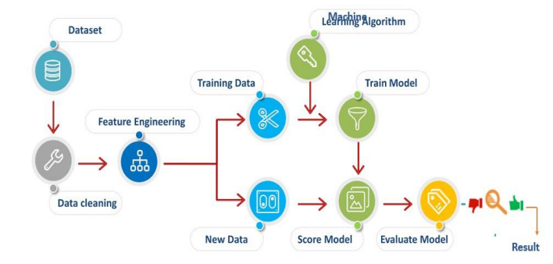The software requirements specification is a technical specification of requirements for the software product.

Figure 4.1.1

It is the first step in the requirements analysis process. It lists requirements of a particular software system. The following details follow the special libraries like sk-learn, pandas, NumPy, matplotlib and seaborn.

**Non-Functional Requirements:**

Process of functional steps,

1. Problem define

2. Preparing data

3. Evaluating algorithms

4. Improving results

5. Prediction the result

**Environmental Requirements:**

1. Software Requirements: Operating System, Windows
2. Tool: Anaconda with Jupiter Notebook

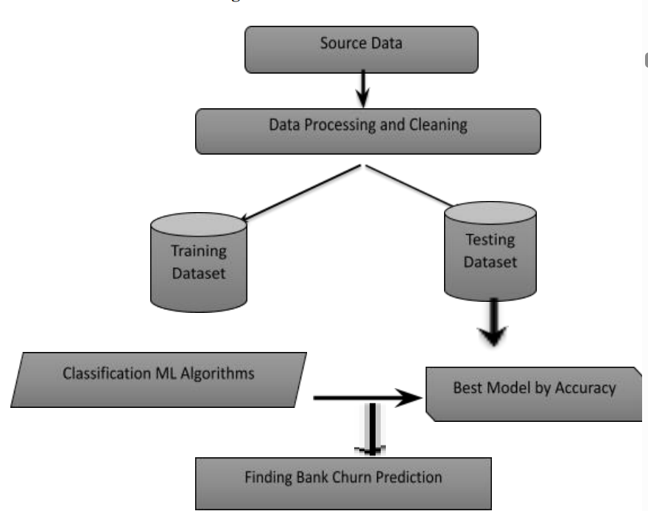**4.2 SYSTEM ARCHITECTURE**

Figure 4.2.1

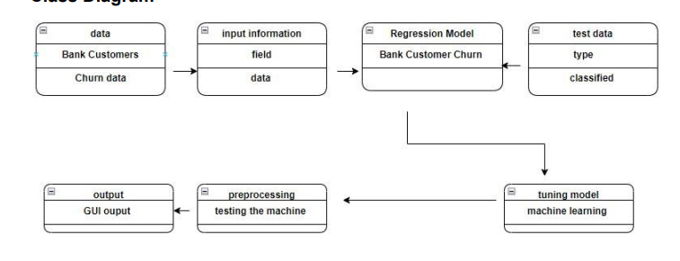Use case diagrams are considered for high level requirement analysis of a system. So when the requirements of a system are analysed the functionalities are captured in use cases. So, it can say that uses cases are nothing but the system functionalities written in an organized manner.

Figure 4.2.2

Class diagram is basically a graphical representation of the static view of the system and represents different aspects of the application. Finally, before making the final version, the diagram should be drawn on plain paper and reworked as many times as possible to make it correct.

**5. RESULT AND DISCUSSION**

**Data Pre-processing**

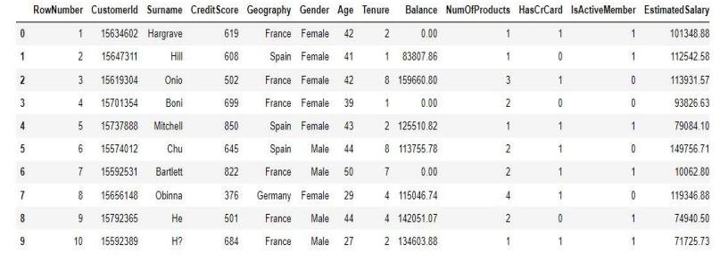Validation techniques in machine learning are used to get the error rate of the Machine Learning (ML) model, which can be considered as close to the true error rate of the dataset. If the data volume is large enough to be representative of the population, you may not need the validation techniques. However, in real-world scenarios, to work with samples of data that may not be a true representative of the population of given dataset. To finding the missing value, duplicate value and description of data type whether it is float variable or integer. The sample of data used to provide an unbiased evaluation of a model fit on the training dataset.

Figure 5.1

The evaluation becomes more biased as skill on the validation dataset is incorporated into the model configuration. The validation set is used to evaluate a given model, but this is for frequent evaluation. It as machine learning engineers uses this data to fine-tune the model hyper parameters. Data collection, data analysis, and the process of addressing data content, quality, and structure can add up to a time-consuming to-do list. During the process of data identification, it helps to understand your data and its properties; this knowledge will help you choose which algorithm to use to build your model.

A number of different data cleaning tasks using Python’s Pandas library and specifically, it focuses on probably the biggest data cleaning task, missing values and it able to more quickly clean data. It wants to spend less time cleaning data, and more 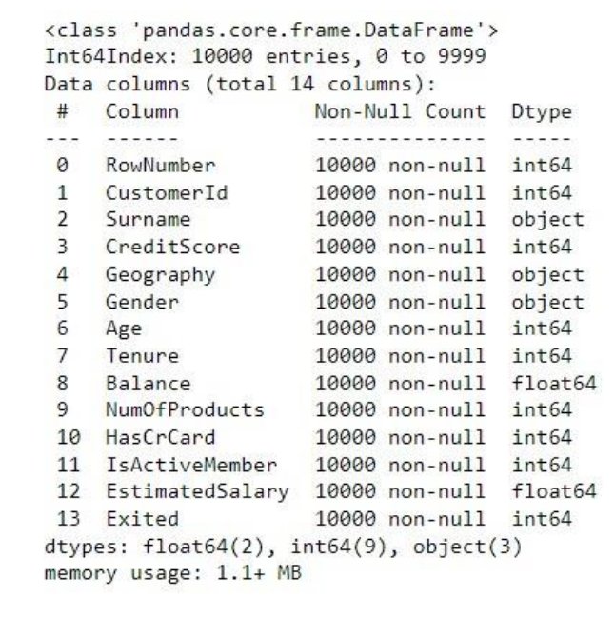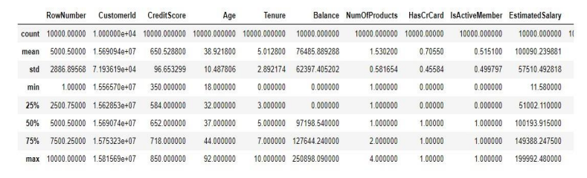time exploring and modelling.

Figure 5.2

Some of these sources are just simple random mistakes. Other times, there can be a deeper reason why data is missing. It’s important to understand these different types of missing data from a statistics point of view. The type of missing data will influence how to deal with filling in the missing values and to detect missing values, and do some basic imputation and detailed statistical approach for dealing with missing data. Before, joint into code, it’s important to understand the sources of missing data. Here are some typical reasons why some data is missing.

● User forgot to fill in a field.

● Data was lost while transferring manually from a legacy database.

● There was a programming error.

● Users chose not to fill out a field tied to their beliefs about how the results would be used

or interpreted

**Data Validation/ Cleaning/Preparing Process**

Importing the library packages with loading given dataset. To analysing the variable identification by data shape, data type and evaluating the missing values, duplicate values. A validation dataset is a sample of data held back from training your model that is used to give an estimate of model skill while tuning model's and procedures that you can use to make the best use of validation and test datasets when evaluating your models. Data cleaning / preparing by rename the given dataset and drop the column etc. to analyse the uni-variate, bivariate and multi-variate process. The steps and techniques for data cleaning will vary from dataset to dataset. The primary goal of data cleaning is to detect and remove errors and anomalies to increase the value of data in analytics and decision making

**Exploration data analysis of visualization**

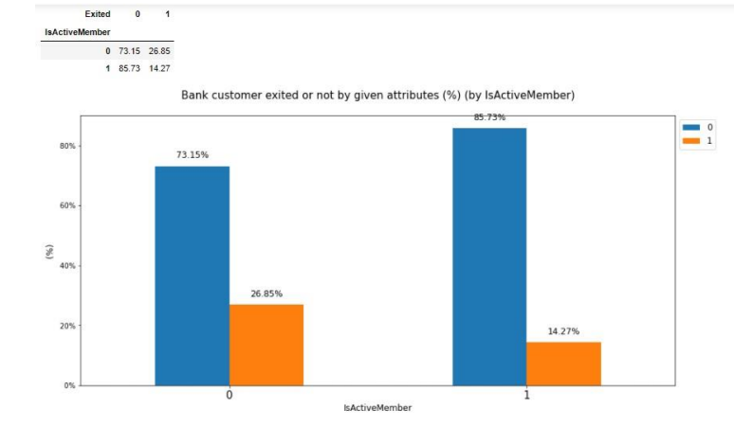Data visualization is an important skill in applied statistics and machine learning. Statistics does indeed focus on quantitative descriptions and estimations of data. Data visualization provides an important suite of tools for gaining a qualitative understanding. This can be helpful when exploring and getting to know a dataset and can help with identifying patterns, corrupt data, outliers, and much more. With a little domain knowledge, data visualizations can be used to express and demonstrate key relationships in plots and charts that are more visceral and stakeholders than

figure 5.3

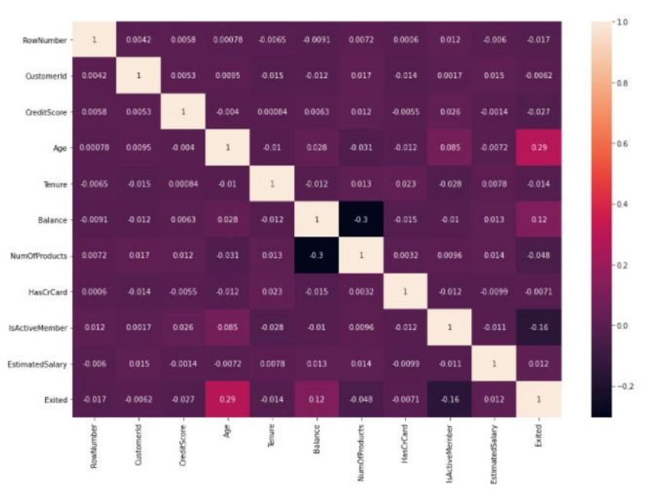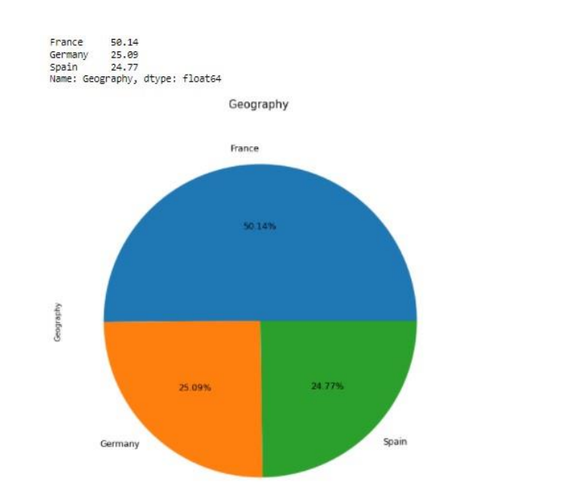of association or significance. Data visualization and exploratory data analysis are whole fields themselves and it will recommend a deeper dive into some the books mentioned at the end.

Figure 5.4

Sometimes data does not make sense until it can look at in a visual form, such as with charts and plots. Being able to quickly visualize of data samples and others is an important skill both in applied statistics and in applied machine learning. It will discover the many types of plots that you will need to know when visualizing data in Python and how to use them to better understand your own data.

How to chart time series data with line plots and categorical quantities with bar charts.

How to summarize data distributions with histograms and box plots.

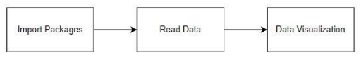**MODULE DIAGRAM**

**Comparing Algorithm with prediction in the form of best accuracy result**

It is important to compare the performance of multiple different machine learning algorithms consistently and to create a test harness to compare multiple different machine learning algorithms in Python with scikit-learn. It can use this test harness as a template on your own machine learning problems and add more and different algorithms to compare. Each model will have different performance characteristics.

In the example below 4 different algorithms are compared:

1. Logistic Regression
2. Random Forest
3. Decision Tree Classifier
4. Naive Bayes

**6. ALGORITHM AND TECHNIQUES**

**Algorithm Explanation -** In machine learning and statistics, classification is a supervised learning approach in which the computer program learns from the data input given to it and then uses this learning to classify new observations. This data set may simply be bi-class (like identifying whether the person is male or female or that the mail is spam or non-spam) or it may be multi-class too. Some examples of classification problems are: speech recognition, handwriting recognition, biometric identification, document classification etc.

**6.1 Random Forest Classifier**

Random forests or random decision forests are an ensemble learning method for classification, regression and other tasks that operate by constructing a multitude of decision trees at training time and outputting the class that is the mode of the classes (classification) or mean prediction (regression) of the individual trees. Random decision forests correct for decision trees’ habit of over-fitting to their training set. Random forest is a type of supervised machine learning algorithm based on ensemble learning. Ensemble learning is a type of learning where you join different types of algorithms or the same algorithm multiple times to form a more powerful prediction model. The random forest algorithm combines multiple algorithms of the same type i.e., multiple decision trees, resulting in a forest of trees, hence the name "Random

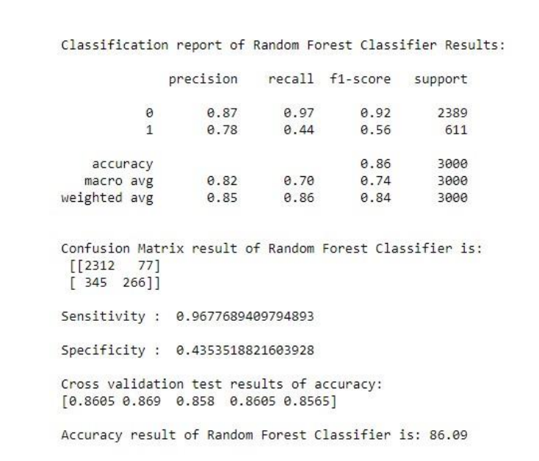Forest". The random forest algorithm can be used for both regression and classification tasks.

The following are the basic steps involved in performing the random forest algorithm:

1. Pick N random records from the dataset.
2. Build a decision tree based on these N records.
3. 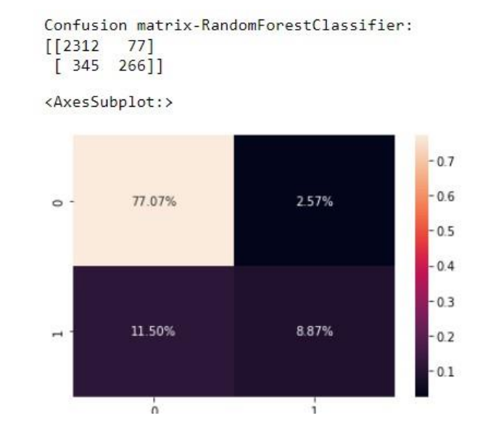Choose the number of trees you want in your algorithm and repeat steps 1 and

Figure 6.2

In case of a regression problem, for a new record, each tree in the forest predicts a value for Y (output). The final value can be calculated by taking the average of all the values predicted by all the trees in forest. Or, in case of a classification problem, each tree in the forest predicts the category to which the new record belongs. Finally, the new record is assigned to the category that wins the majority vote.

**7. References**

1. Academic Papers:

- Breiman, L. (2001). Random Forests. Machine learning, 45(1), 5-32.

- Liaw, A., & Wiener, M. (2002). Classification and regression by randomForest. Rnews, 2(3), 18-22.

2. Books:

- James, G., Witten, D., Hastie, T., & Tibshirani, R. (2013). An Introduction to Statistical Learning. Springer.

- Hastie, T., Tibshirani, R., & Friedman, J. (2009). The Elements of Statistical Learning. Springer.

3. Online Articles and Documentation:

- Scikit-learn Documentation for Random Forest: [Scikit-learn Ensemble Methods] (https://scikit-learn.org/stable/modules/ensemble.html#random-forests)

- Analytics Vidhya. (2019). Understanding Random Forests - A Practical Guide. [Link](<https://www.analyticsvidhya.com/blog/2018/11/a-guide-to-understanding-random-forests/>)

4. Research Papers:

- Vafeiadis, T., & Chatzis, S. P. (2015). Bank Customer Churn Prediction with Artificial Neural Networks. Procedia Computer Science, 65, 976-983.

5. Journals and Articles:

- Duan, K., Ke, Y., & Liu, Q. (2017). A Hybrid Model of Random Forest, K-Nearest Neighbours, and Genetic Algorithm for Predicting Customer Churn. Mathematical Problems in Engineering, 2017.

6. Online Platforms and Tutorials:

- Kaggle Datasets and Kernels related to Customer Churn and Random Forest implementations.

**8. Conclusion**

The analytical process started from data cleaning and processing, missing value, exploratory analysis and finally model building and evaluation. The best accuracy on a public test set is a higher accuracy score will be found out. This application can help to find the Prediction of Bank Churn, which helps to give more support to customers.

**Future Work**

Bank Churn prediction to connect with real time AI models.

To optimize the work to implement in an Artificial Intelligence environment